# Jenkins Installation Guidelines

# 

1. **Introduction**

Jenkins is an open source automation tool written in Java with plugins built for Continuous Integration purpose. Jenkins is used to build and test your software projects continuously making it easier for developers to integrate changes to the project, and making it easier for users to obtain a fresh build. It also allows you to continuously deliver your software by integrating with a large number of testing and deployment technologies.

**1.2 Overview:**

With Jenkins, organizations can accelerate the software development process through automation. Jenkins integrates development life-cycle processes of all kinds, including build, document, test, package, stage, deploy, static analysis and much more.

The image below depicts that Jenkins is integrating various DevOps stages:

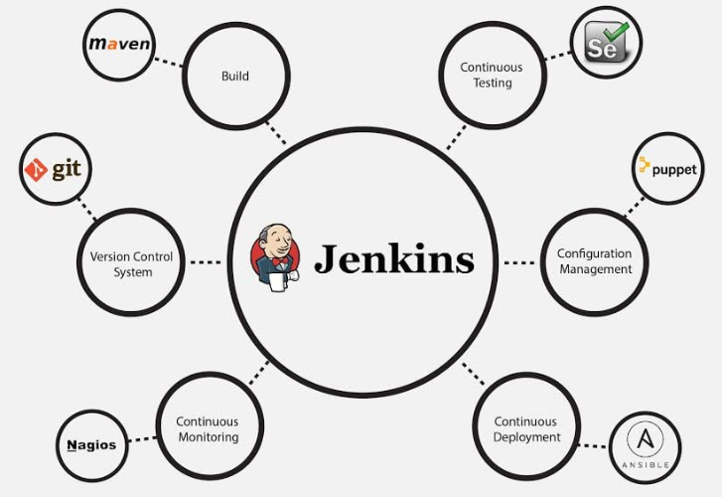

**1.3 Readership:**

Attended audience are –

* Associate involve in project work and continuous integration.
* Business analyst and designer.
* Build associate having knowledge of application & deployment.
* Associate with .Net application development knowledge.

**1.4 Constrains:**

**1.5 Version History:**

|  |  |
| --- | --- |
| Version | Description |
|  |  |
|  |  |

**1.6 Reviewer:**

|  |  |
| --- | --- |
| Reviewer | Role |
|  |  |
|  |  |
|  |  |

**1.7 Approvers:**

|  |  |  |  |
| --- | --- | --- | --- |
| Approver | Role | Approve Date | Role |
|  |  |  |  |
|  |  |  |  |
|  |  |  |  |

1. **Requirement To be Delivered**
   1. **In Scope**

* Jenkins Installation.
* Configure the HTTP Proxy Settings.
* Configure the windows environment for secure HTTP communication behind the firewall.
* Configure Jenkins system to map with Perforce.
* Configure Email Notification to Team members in case build fail.
* Installation of plugins required to build the project and solution file.
* Map SSL certificate and nuget certificate, so Jenkins can communicate internet and install .Net packages runtime.
* Create new project environment in Jenkins for TDRP and configured.
* Jenkins Build environment
* Defined source code management to automate the build trigger as soon as new code check-in into perforce.
* Configure the Jenkins Pipelines for continuous integration between Dev, SIT and Prod environment.
* Integrate selenium.
* Use Docker to create, deploy, and run applications by using containers.
  1. **Out Of Scope**

This document is not holding any information of estimation cost and weigh.

* 1. **Assumption**

Assumption has been stated in the section ….

1. **Pre-requisites**

Before you proceed to install Jenkins in your windows system, there are some prerequisites for Jenkins to install Jenkins in your computer.

**Hardware requirements:**

• You need minimum 256 MB of RAM in your computer or laptop to install Jenkins

• You need at least 1 GB of space in your hard drive for Jenkins.

**Software Requirements:**

• Since Jenkins runs on Java, you need either latest version of Java Development Kit (JDK) or Java Runtime Environment (JRE).

* 1. **Release Types**

Jenkins releases two types of versions based on the organization needs.

* Long-term support release
* Weekly release
  1. **Long term support release (LTS):**

Long-term support releases are available every 12 weeks. They are stable and are widely tested. This release is intended for end users.

* 1. **Weekly release:**

Weekly releases are made available every week by fixing bugs in its earlier version. These releases are intended towards plugin developers.

We will use the LTS release though the process remains the same for Weekly release.

1. **Steps to configure the environment for Jenkins:**

If using windows server, first ask networking team to enable the internet on machine – You can reach to Dave Lewis for the same.

Active Internet – since the servers it is disabled by default, for user profiles, so do the following.

* Open Internet Options

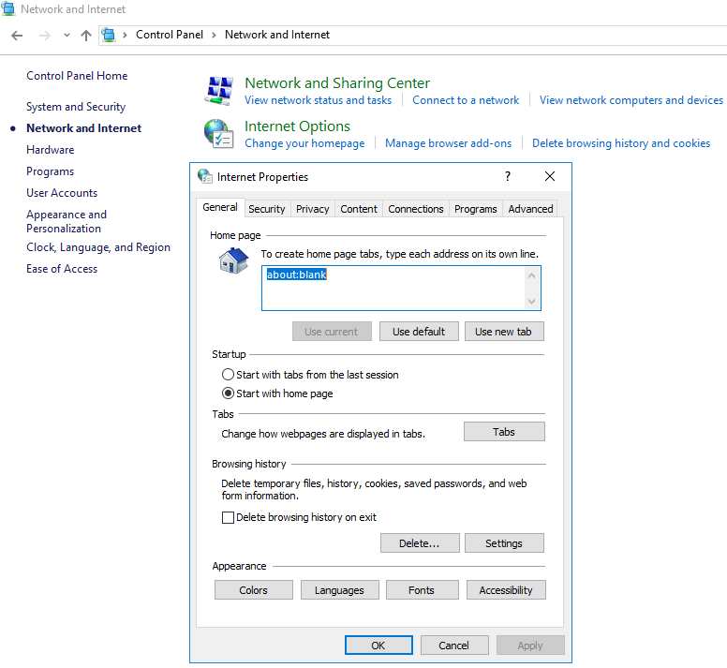

* Go to Connections 🡪 LAN Settings

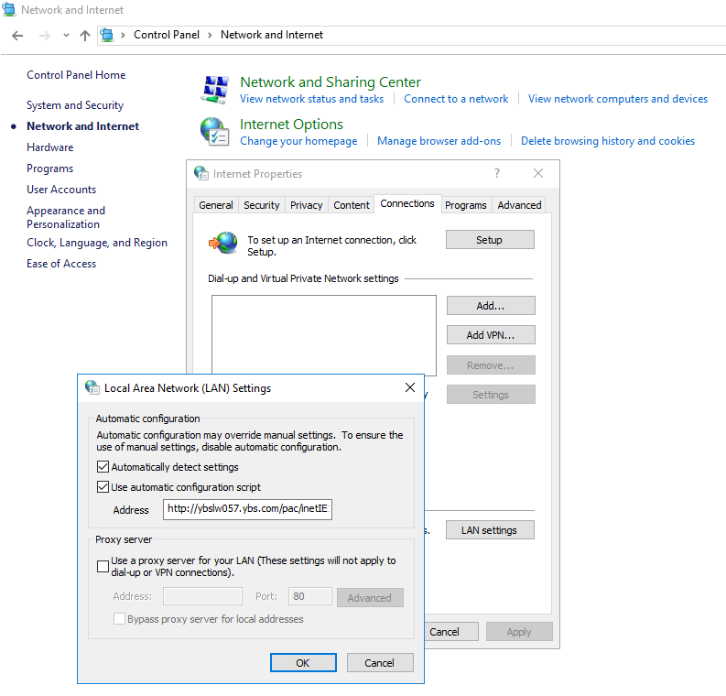

* Use Automatic Configuration Script' enter "[http://ybslw057.ybs.com/pac/inetIE11.pac](http://ybslw057.ybs.com/pac/inetIE11.pac%20)
* Now try to explore internet, it should be working.

1. **Software Required to Install for .Net Based Application**
   1. **Install JDK and configured the Path**
2. On the Windows desktop, right-click My Computer.
3. In the pop-up menu, click Properties 🡪 Click on Advanced System Settings

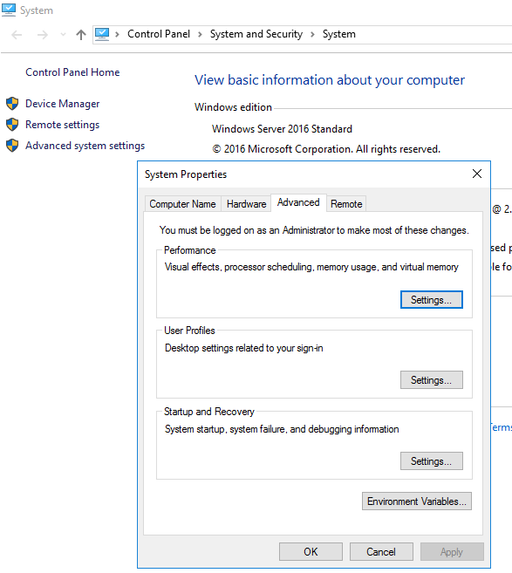

1. Set the system variable for JAVA_HOME and JRE_HOME as shown below

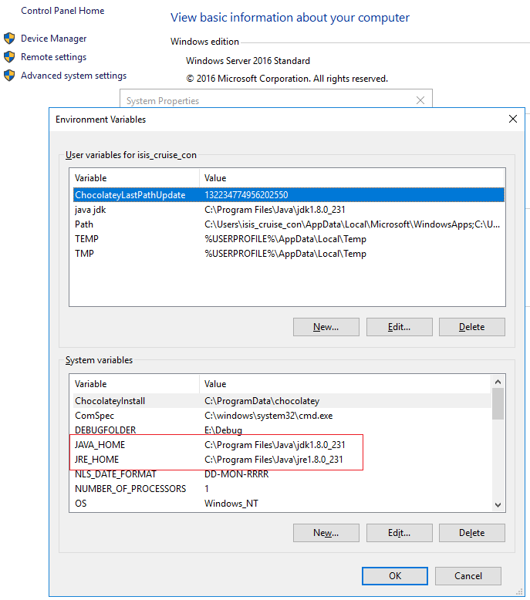

1. Click on Path variable and set the JDK path and MSBuid path (Usually MSBuild path set automatically when you install the .Net Core Build tool)

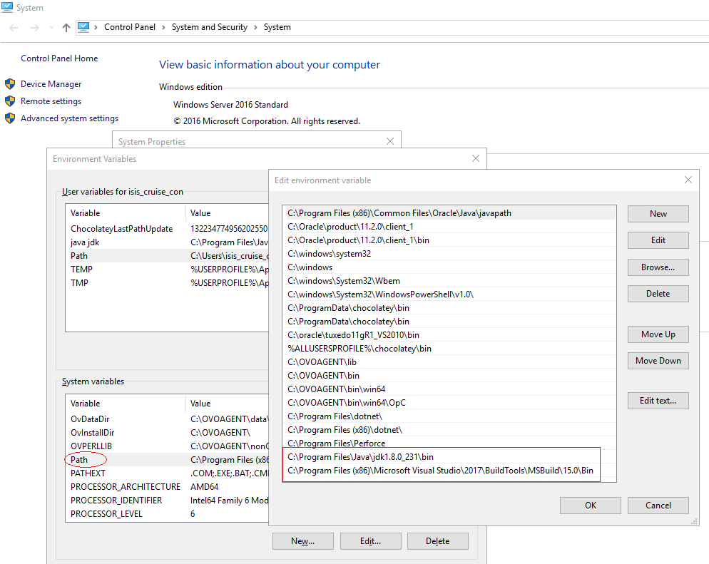

* 1. **Install dotnet hosting 2.2.0**

Download .Net Hosting 2.2.0 and install into machine (It is only required for the application developed in .Net core)

* 1. **Install Visual Studio Installer**

Open Visual Studio Installer --> Install .Net Core Build Tool

* 1. **Install perforce**
  2. **Install dotnet-sdk-2.2. for win-x64**

**Note:** Due to security and other setting, you may not be able to install all software, So better to install chocolatey on machine, then use it for other software installation.

<https://chocolatey.org/docs/how-to-setup-offline-installation>



You can use above file to install it offline, please follow the instruction as below.

* Open PowerShell ISE

* Set-ExecutionPolicy Bypass -Scope Process -Force; iex ((New-Object System.Net.WebClient).DownloadString('C:\Users\isis_cruise_con\Desktop\install.ps1'))

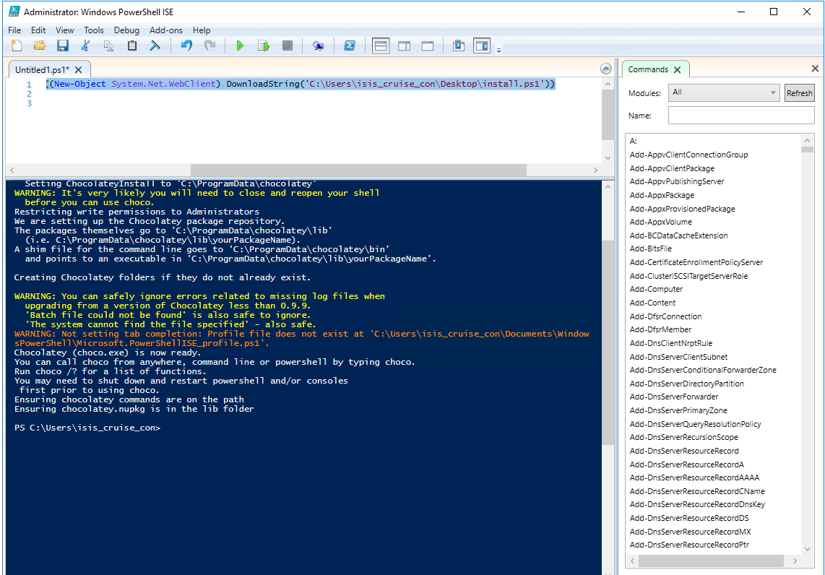

1. **Jenkins to Communicate HTTPS**

In remote server environment, Jenkins is generally unable to communicate on secure HTTP. I order to resolve this issue; you need to configure the SSL certificate of your organisation.

* First download the certificate, and start running the command in Powershell as below
* C:\Program Files (x86)\Jenkins\jre\lib\security>keytool -list -keystore cacerts
* Enter keystore password: changeit
* It will list many records. When Done
* C:\Program Files (x86)\Jenkins\jre\lib\security>keytool -importcert -keystore cacerts -storepass changeit -file C:\Users\isis_cruise_con\Desktop\Cert\ybscert.cer

1. **Process to Install & Configure Jenkins**
   1. **Download the Jenkins**

Download the Jenkins (Long Term Support) for Windows from below

<https://jenkins.io/download/>

* Unzip the file to a folder and click on the Jenkins **exe** file.

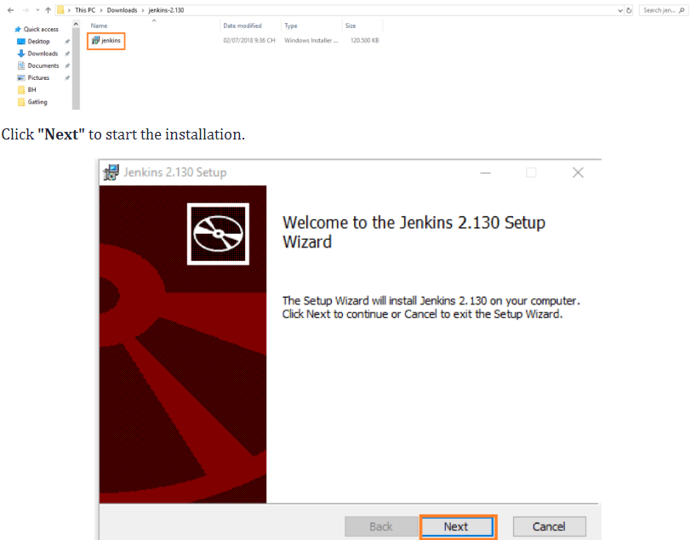

* Click the **"Change..."** button if you want to install Jenkins in another folder. In this example I will keep the default option and click on the **"Next"** button.

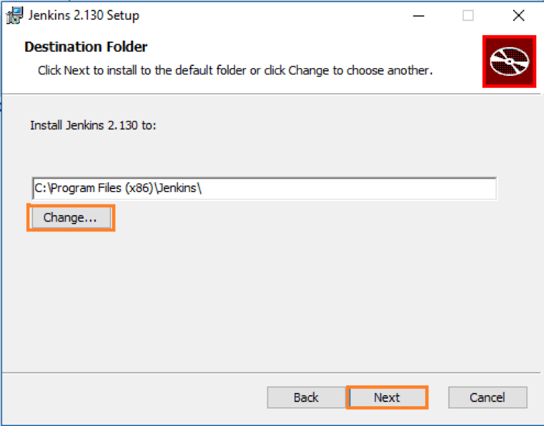

* Click the**"Install"** button to start the installation process.

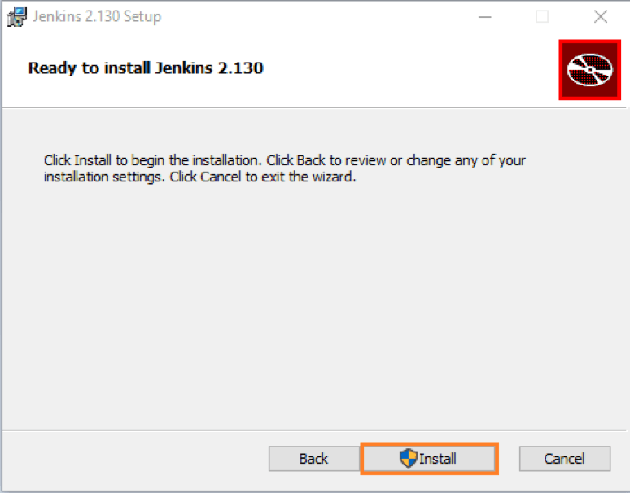

* The installation is processing.

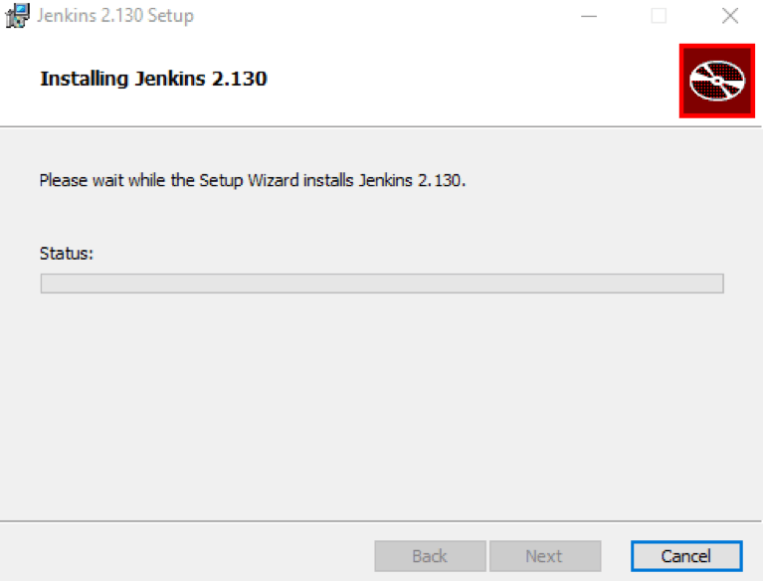

* When done, click the **"Finish"**button to complete the installation process.

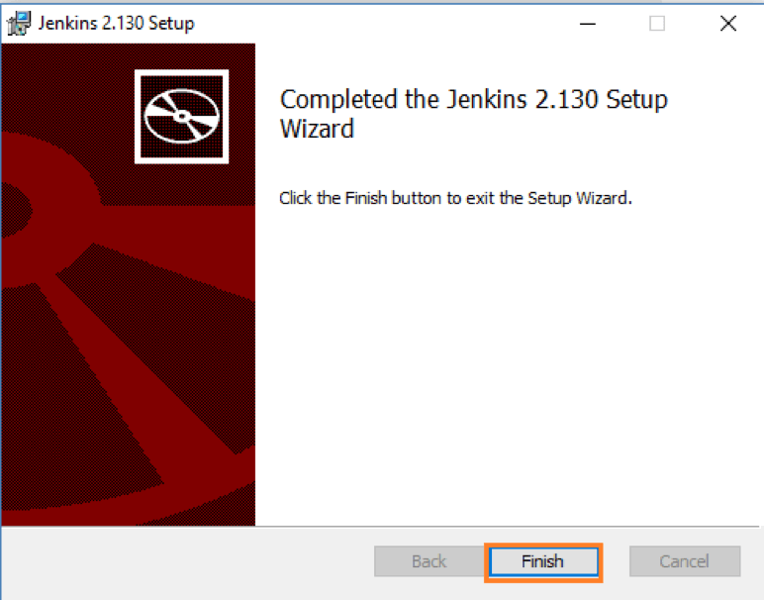

* You will automatically be redirected to a local Jenkins page, or you can paste the URL [http://localhost:8080](http://localhost:8080/) in a browser.

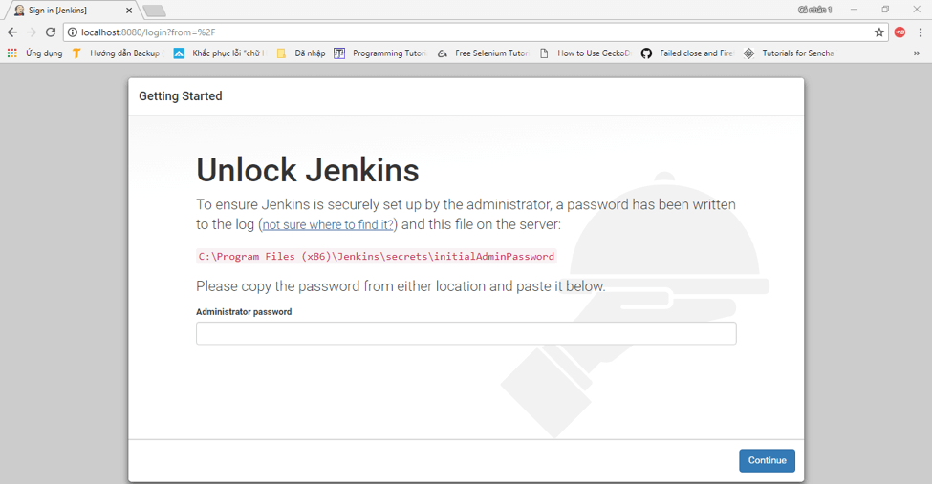

* To unlock Jenkins, copy the password from the file at**C:\Program Files (x86)\Jenkins\secrets\initialAdminPassword** and paste it in the **Administratorpassword** field. Then, click the **"Continue"** button.
* Now, click **"Start using Jenkins"** to start Jenkins

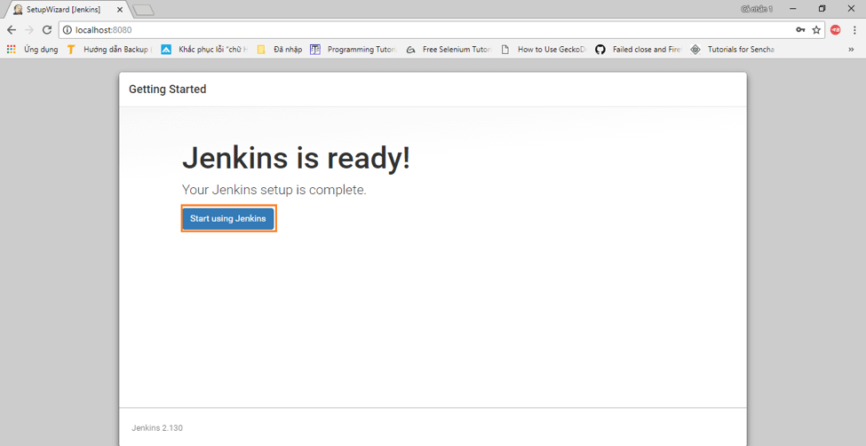

* Finally, here is the default Jenkins page.
* Go to Manage Jenkins 🡪 Manage Plugins 🡪 Advanced
* Define the HTTP proxy configuration, if you not aware, ask to networking team
* Set the proxy and validate the proxy for both (HTTP and HTTPS)

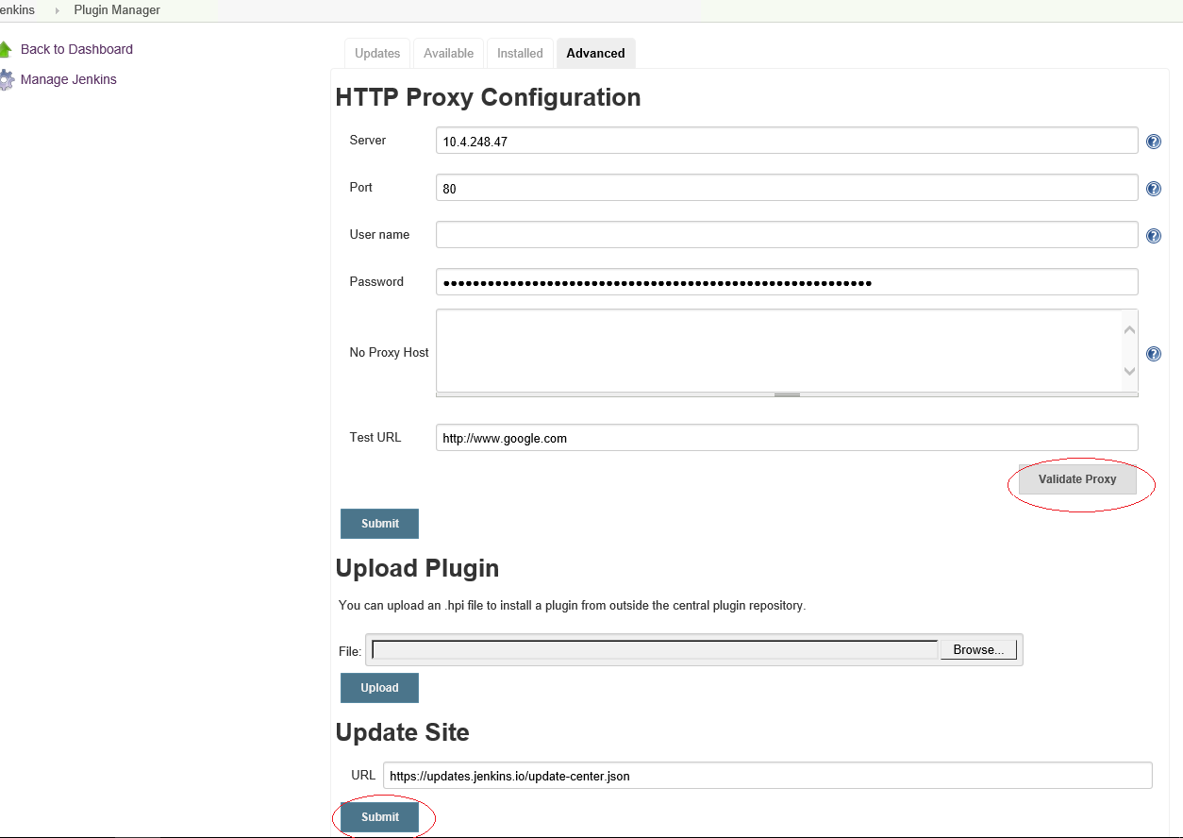

* Now go to available tab 🡪 and install all the required proxy as shown below

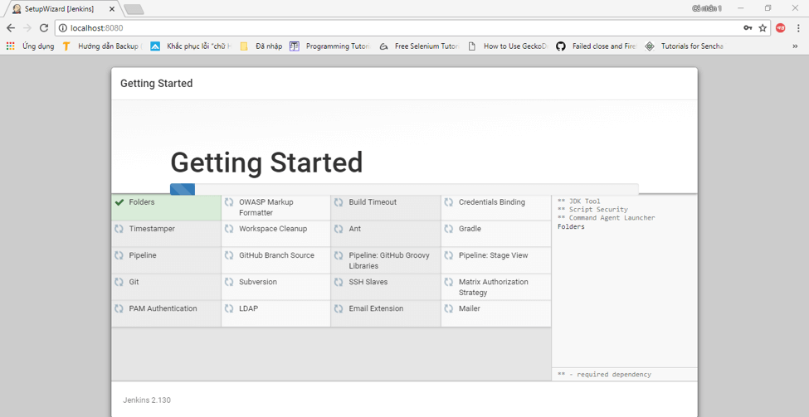

* Install “P4 Plugins”, “Nuget Plugin”, “MS Build Plugin”, “MS Test Plugin”
  1. **MSBuild Configuration**

Click on Manage Jenkins 🡪 Global Tool Configuration

Define the MSBuild configuration here as below

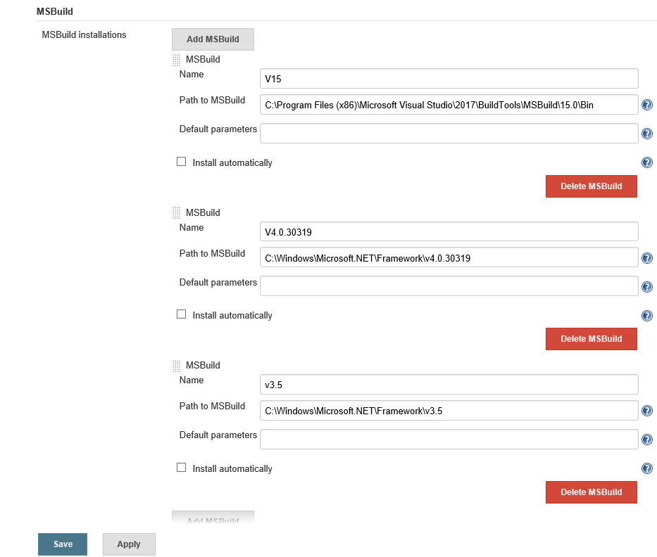

* 1. **Configure System**

Click on Manage Jenkins 🡪 Configure Systems

Go to Perforce: Save Configuration 🡪 Perforce Credentials 🡪 Click add and set the configuration for perforce access

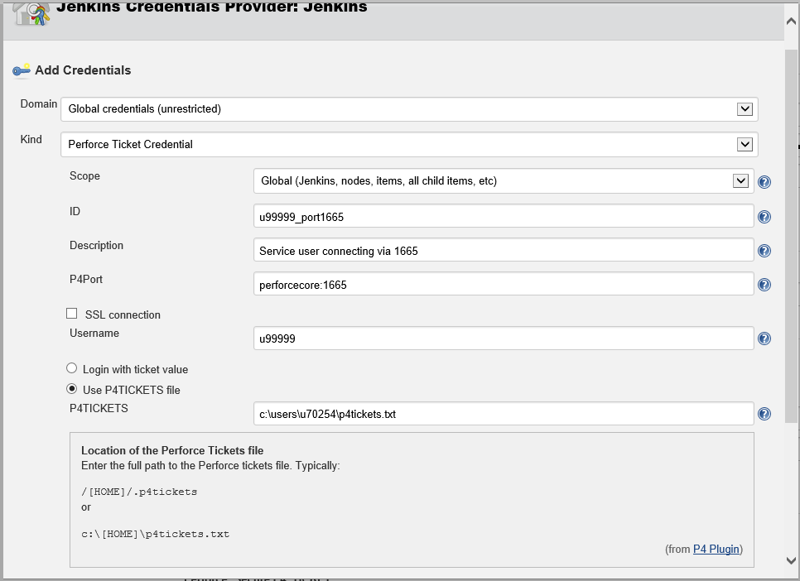

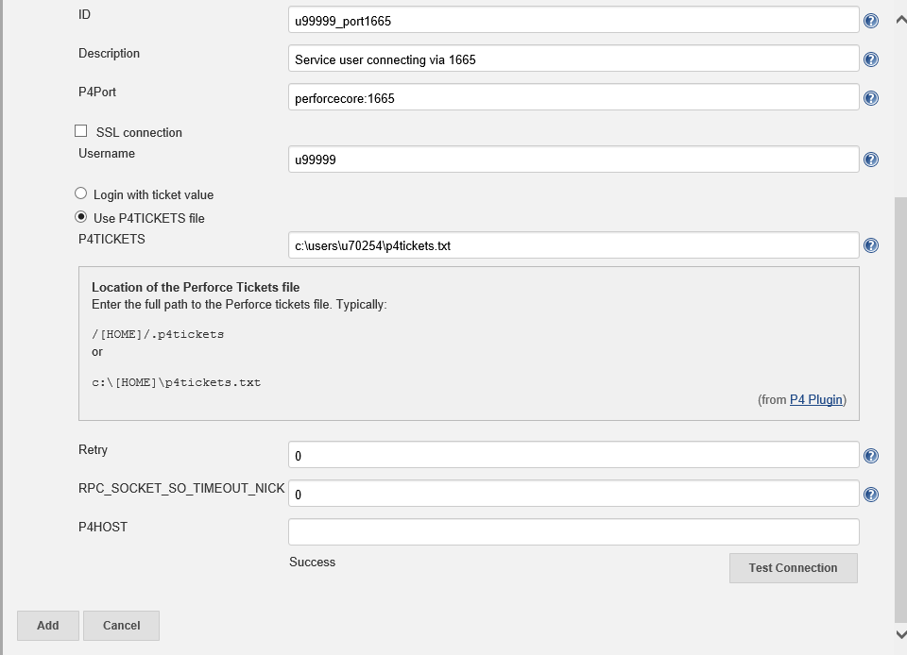

Use below attached P4Ticket, and place it to somewhere as shown in above



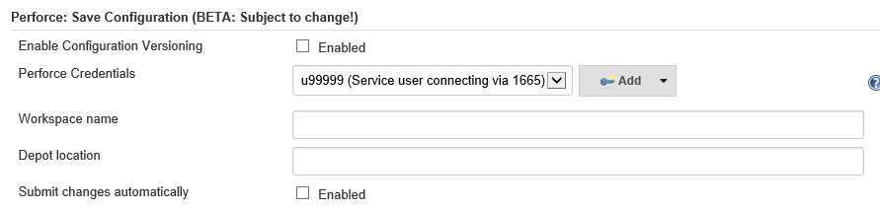

* 1. **Setup Email-Notification**

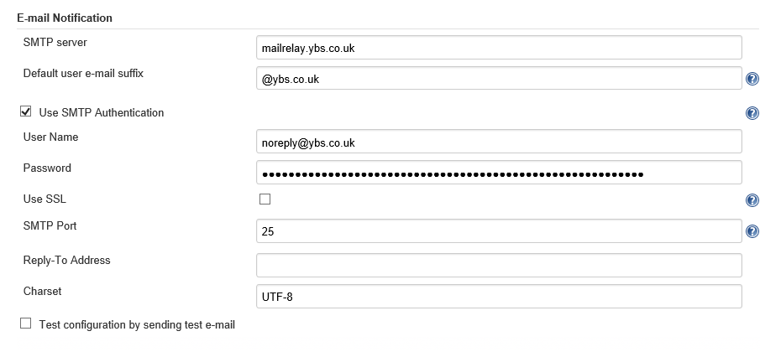

* 1. **Extended E-mail Notification**

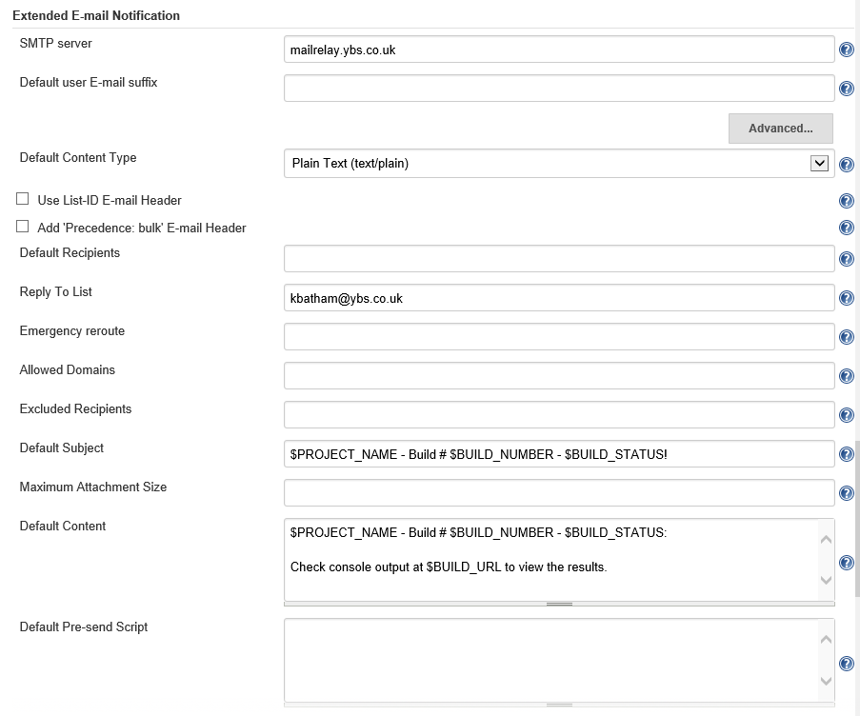

* 1. **Configure Global Security**

[Let](https://azurecitadel.github.io/labs/) it be default

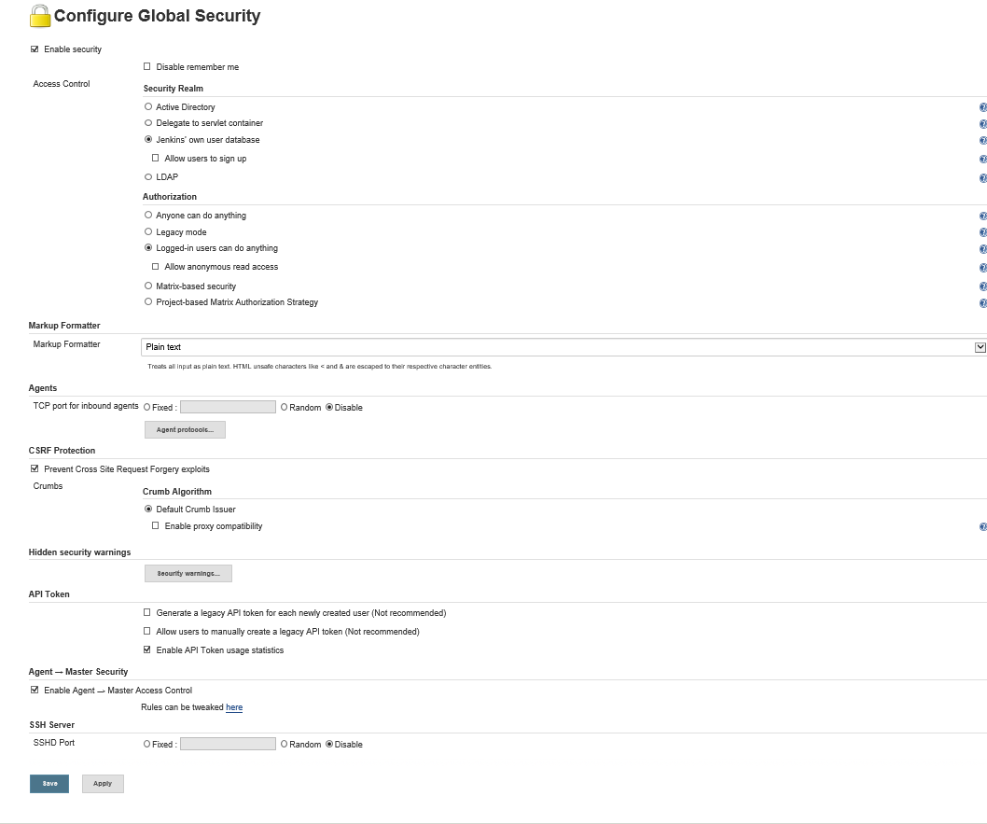

* 1. **Manage User**

Click on Manage Jenkins 🡪 Manage User

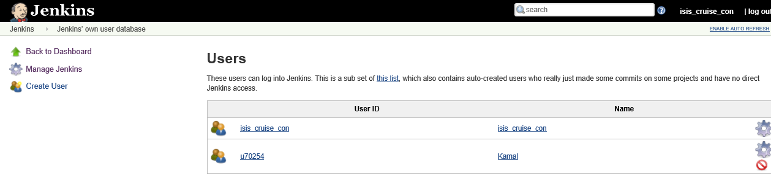

* 1. **Edit Jenkins.config file**

Go to C:\Program Files (x86)\Jenkins

Update argument field in Jenkins.config file

**<arguments>-Xrs -Xmx256m -Dhudson.lifecycle=hudson.lifecycle.WindowsServiceLifecycle -jar "%BASE%\jenkins.war" --httpPort=8080 --httpListenAddress=127.0.0.1 --webroot="%BASE%\war"</arguments>**

1. **Add New Project for CI/CD**

Click New Item 🡪 First Select FreeStyle Project or Folder for Sub directory

Create your directory for new project

* 1. **Configure the Project**

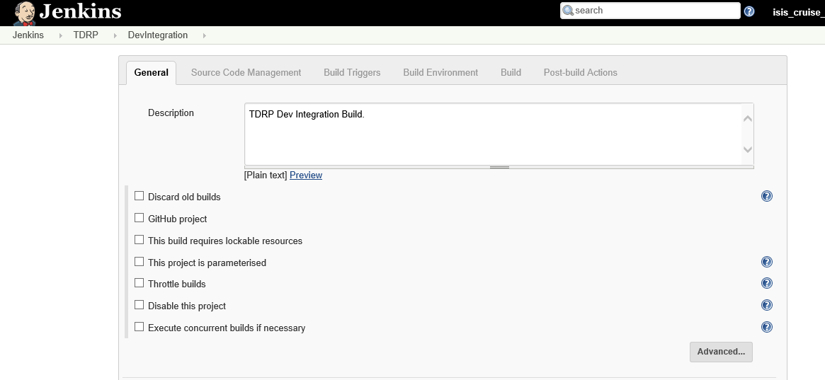

* Define workspace in Source Code Management

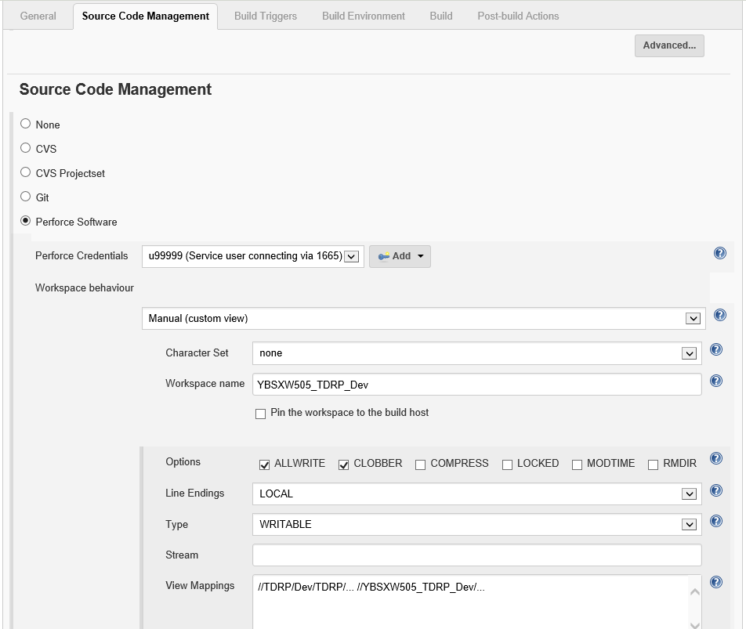

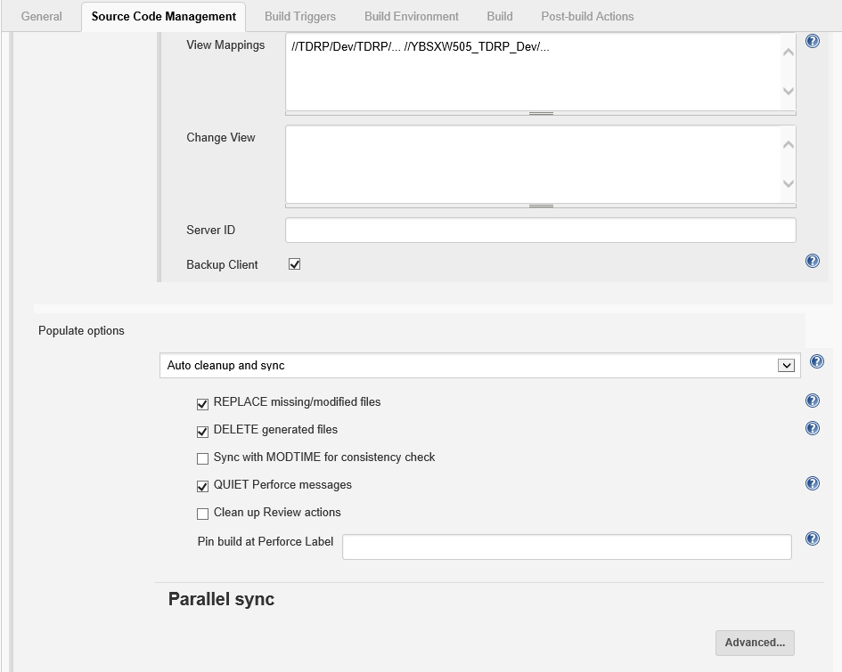

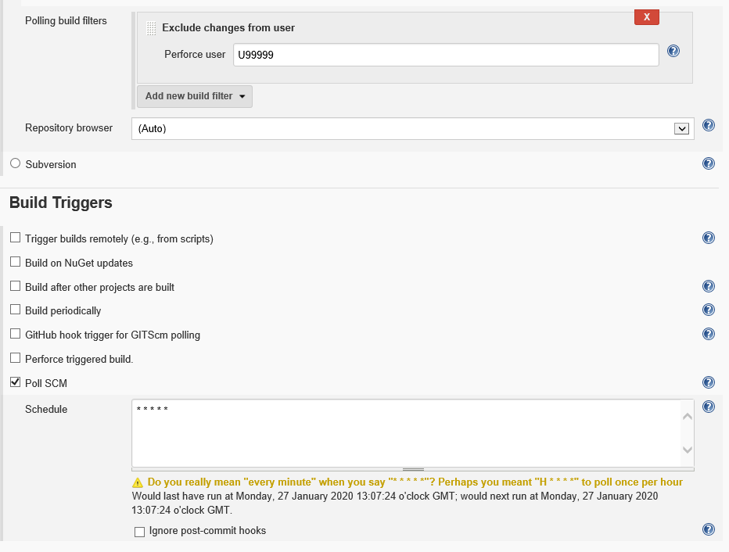

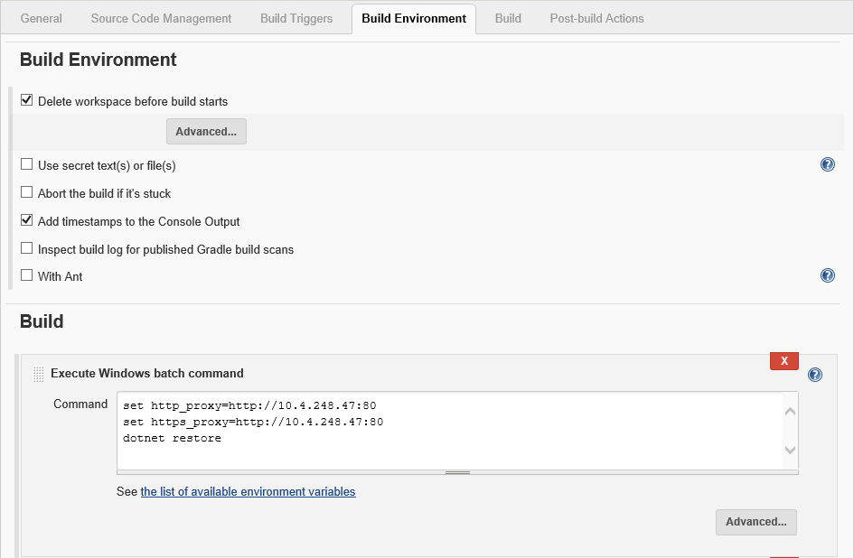

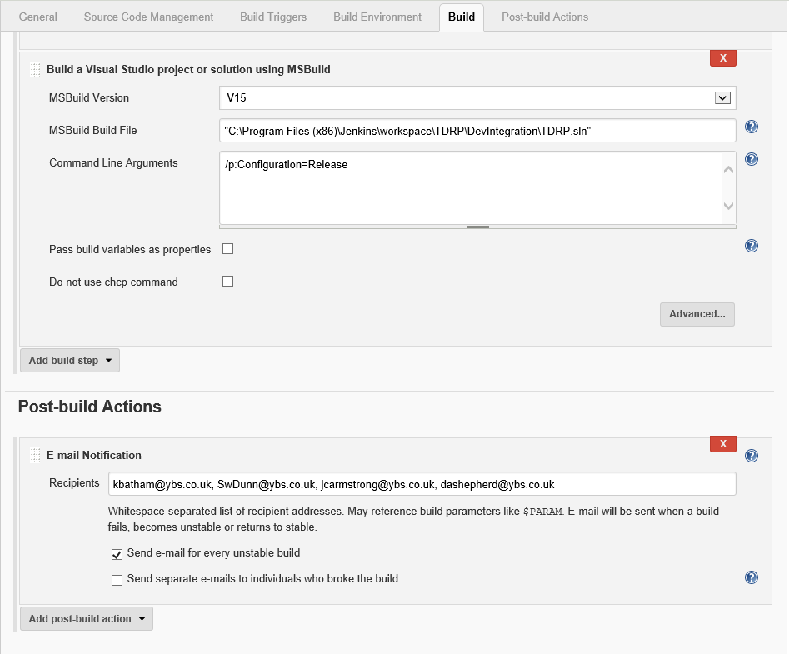

* 1. **Update Nuget.Config**
* Windows search 🡪 %appdata% 🡪 Double Click on NuGet Folder
* Open file in editor and set the proxy as below

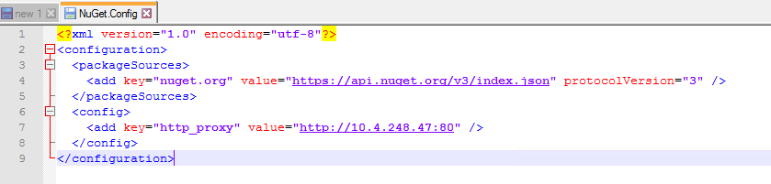

* Verify the same inC:\Windows\System32\config\systemprofile\AppData\Roaming\NuGet
* Verify the same inC:\Windows\SysWOW64\config\systemprofile\AppData\Roaming\NuGet